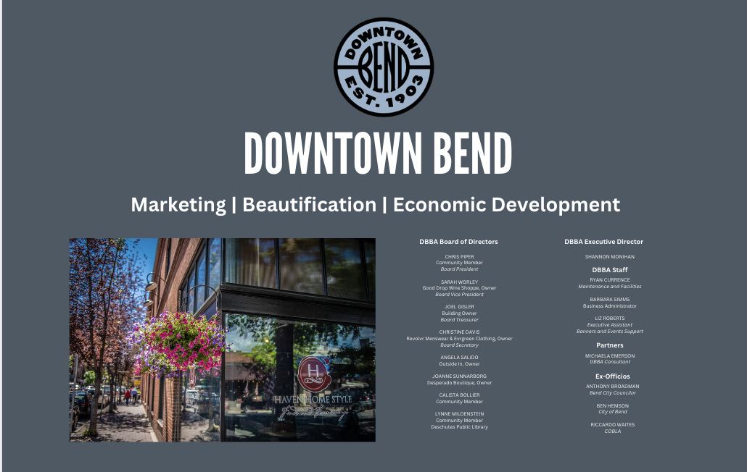
DBBA Board of Directors Agenda
Wednesday, January 18, 2023
In Person: DBBA Office 916 NW Wall Street
Zoom: https://us02web.zoom.us/j/84949443314

Present: Chris Piper, Calista Bollier, Joel Gisler, Lynne Mildenstein, Angela Salido, Joanne Sunnarborg, Liz Roberts, Barbara Simms, Shannon Monihan, Ryan Currence, Anthony Broadman, Ben Hemson
Guest: Tobi Marx
Absent: Sarah Worley, Christine Davis, Michaela Emerson, Riccardo Waites

- Administration 8-8:05

Meeting called to order at 8:07 by Piper
Sunnarborg moved to approve the minutes from November 16, 2022; Piper seconded. Minutes were approved unanimously.

- Budget Update 8:05-8:15 (Chris, Sarah, Shannon)

Monihan, Piper and Simms met in December to discuss the budget. It was noted that Treasurer Gisler was not present at this meeting as calls to him were not returned.
Monihan emphasized that the budget is evolving to support more marketing and consistent, monthly income versus one-off event planning and fund raising.
Current budget reports that DBBA is under budget by $50,000. Councilor Broadman suggested a year-to-year budget comparison could be helpful.

- State of the Union, Shannon Monihan, Executive Director 8:15-8:55
  - Newsletter

  - New Member Packet
Monihan distributed draft of new Welcome Packet for DBBA. Highlights include:
- DBBA’s mission
- Marketing and promotional opportunities for DBBA member businesses
- New monthly, promotions calendar for the year
- How a business can be “supersized”
- Downtown beautification support and decorations
- Economic Development through partnerships, grants and fundraising
- EID information and boundary map

Monihan stated the calendar is a working document and appreciates more ideas especially for First Friday Follies. Roberts will send draft of current ideas via email to board members for feedback by February 15.

Questions about using the breezeway for activities were raised. Hemson noted that the two buildings and ceiling between the two, were privately owned. He expressed no concern for using sidewalk for chalk drawings, for example, as there is an easement for the ground.

- Board Member Replacement Discussion 8:55-9:00
Monihan shared list of potential candidate to fill the one (1) vacancy on the board. Simms noted that current board member terms are ending in April and June of this year. Typically names and biographies for these positions are posted in March. Piper recommended to post all new terms and vacancies at that time so that board members start terms in May 2024. Board members agreed.

- Downtown Bend Pulse Report 9:00-9:10

Piper and Monihan reiterated both wanted Gisler to be more available as treasurer to talk about budget.

Monihan still needs to meet one-on-one with Salido, Davis, and Gisler

- District 1 (Joel)
- District 2 (Chris)
- District 3 (Cali)
- District 4 (Sarah)
- District 5 (Joanne)
- District 6 (Christine)
- District 7 (Lynne)
- District 8 (Angela)
- District 9 (Joanne)

- City of Bend State of Affairs 9:20-9:45
  - Councilor Anthony Broadman
Important that goals of DBBA are incorporated into the Council’s goals and priorities. Monihan will be in Council’s Listening Session meeting on January 19 at 11:00 am. Broadman requested that DBBA drill down to the one or two thinsg that DBBA needs from council. Examples include:
- Continue to express the $2.4 million allocation be dedicated to the support and stewardship of downtown Bend businesses
- Hawthorne bridge connection and corridor from downtown to central area
- Parking concerns and making sure DBBA interests are expressed
- DBBA should be involved in transit discussions
- Better greenway programs to get people downtown (EG: microtransit; biking)

Broadman noted that having Monihan present and engaged at council meetings has been helpful to the DBBA.

  - City Goal Setting Meeting (Hemson)

See notes above from Broadman above.
Hemson also recommended focusing on 1 or 2 goals and follow up with an email or letter council.

  - Parking Update (Tobi Marx)

Marx gave presentation that highlighted changes in the downtown parking garage and what to expect in the coming months. Of note is the automated parking guidance system that shows indicates, in real time, where parking is available.
Marx indicated that 2022 will be the busiest parking year for revenue (Jan –Dec) surpassing 2021. Also noted that he and his staff are working to get more data about who is parking where and when.
Marx shared that there will be more cameras in the garage area, first in the elevators and then in stairwells and by entries.

- Public Comments and Pre-Approved Presentations 9:45-9:55
No public comments.

- Friends of Downtown Bend 9:55-10
No report.

Meeting adjourned at 9:49.

Lynne Mildenstein
digitally signed 1/18/2023
Signature:
Name: Lynne Mildenstein
DBBA Position: DBBA Board Member
Date: January 18, 2023

