How to alert the City of Bend to a Needed Repair, Situation, or Complaint in Downtown Bend

The DBBA is happy to help you with everything in Downtown that is within our scope. However, sometimes there are things outside of our scope that occur and need City of Bend attention. Please help us alert the City of Bend to these situations by filling out a Citizen Service Request (CSR). Here’s how:

Go to https://www.bendoregon.gov/services/applications-forms/service-request. I would recommend adding this page to your bookmarks so that it’s easy to find in the future.
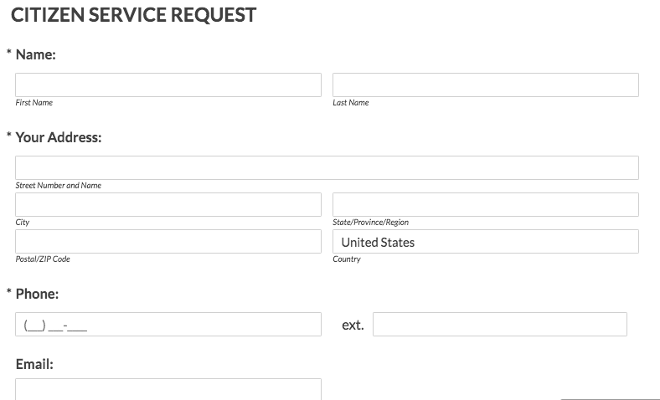

Fill your information into the form
that looks like this:

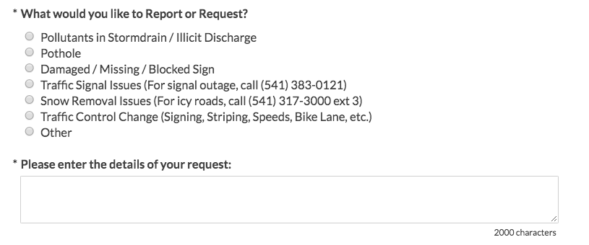
Select the appropriate bubble and describe
your situation. Choose “Other” for anything
not on this list. This could include event
concerns, parking concerns, problems in
an alleyway, etc. If you want a response from
the City – make sure to request one in this
area of the form!

Then, attach a photo (if you have one)

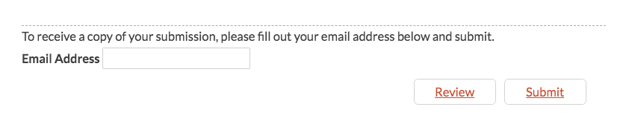
Then (this part is important), put our
email address (downtownbend@gmail.com)
in the area of the form that will provide us with a copy of your request. This will allow us to track requests and make sure that Downtown issues are being resolved.

By using this CSR, you will not only get your issue resolved, but you will help the City gather metrics to make sure that Downtown has sufficient resources in the future. THANK YOU!!

If you don’t know if your issue is an issue for the DBBA to resolve or the City to resolve, go ahead and complete the form. Anything in the DBBA scope will be passed along to us. Here are just a few examples that might be helpful:

DBBA Scope of Work  Sweeping the sidewalks & picking up trash  Removing snow from the sidewalks  Downtown banners  Downtown flowers & flower baskets  Downtown Directory Kiosks | COB Scope of Work  Cleaning the alleyways, streets, garbage areas  Removing snow from a road, alley or parking lot  Cleaning trash and debris left over from an event  Parking signage, payment kiosks, damaged stalls  Flooding
For utility emergencies call 541-317-3000

