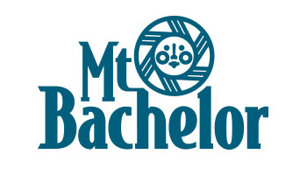
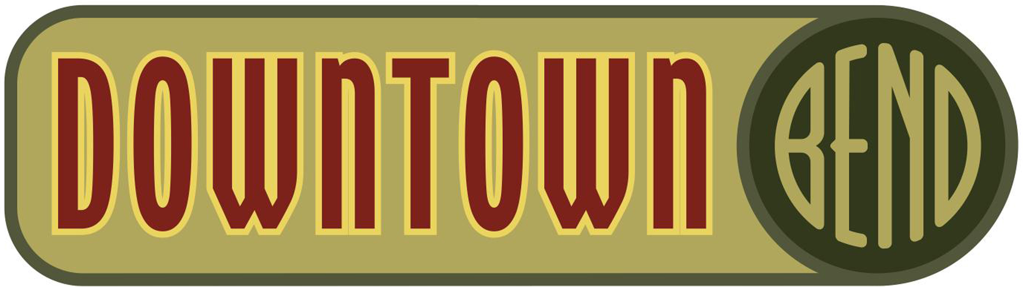

Welcome Mt. Bachelor Ski Groups to Downtown Bend!
The following businesses have special deals & discounts JUST FOR YOU! All you need to do is tell them that you are a part of the ski group to receive your discount.

Books, Boutiques. Gifts, & Jewelry

Dudley’s Bookshop Café – Buy any book valued at $15 or more, and get a free 8oz espresso drink or tea. (1 per customer per day)
Local Joe Jeans - Free Local Joe T-Shirt with any purchase over $50
The Feather’s Edge - 10% off all full-priced items
Cowgirl Cash- Special deals and small tokens of appreciation special for your group!
Lotus Moon-10% off storewide
Jeffrey Murray Photography - 10% off
Princess Athletic - 20% off one regular priced item
Tactics – 15% storewide on our selection of snowboard and skateboard gear, shoes and clothing
Footzone - 10% off any regularly priced items storewide.
Bendy Dog - 10% off storewide
Leapin’ Lizards Toy Company - 10% off storewide
Faveur Unique Boutique - 10% off storewide
Sunstone Store – Make your visit to Bend more than just great memories! Oregon Sunstone, our state gemstone in Champagne color is discounted 50% for Mt. Bachelor ski groups!
Red Pinecone – FREE Bend Logo Silipint Shot glass with $25 Purchase
Cozy in Bend – 15% off storewide
LuLu’s Boutique – 10% off storewide
Cascade Cottons – 10% off regularly priced apparel
Frameworks – Purchase a photo frame and get a free digital print, also shipping is only $5! You can upload your ski vacation photo and they will print if free of charge when you purchase a photo frame. Use promo code “SKIGROUP” at checkout and get an additional 20% off the order! www.highdesertframeworks.com
Oregrown – 10% off storewide!
Oregon Body and Bath – 10% off storewide
Forge Humanity – 10% off storewide
CC McKenzie – 15% off on purchases of over $100, regular price items.

Coffee, Cocktails & Restaurants

Velvet Lounge - Happy Hour pricing all night! Food $6, drafts $4, wine $5, Moscow mule $6, Blue Velvet $6
White Water Taphouse - $1 off each person’s first beverage
Astro Lounge - Buy one get one free appetizer
5 Fusion Sushi - 10% off all food
Pizza Mondo – After Mountain special (3:30-5:30): Two slices of pizza and a pop $5.50, swap in a small beer for $7.50, upgrade to a pint for $8.50
Mantra Indian Kitchen – 15% of on al orders over $50 and happy hour drinks for all skiers!
10 Below – 10% off Total bill
Beach Hut Deli – 10% discount + $2 pints of selected microbrews Mon-Fri 3pm to close.
Sidelines Sports Bar – 20% VIP discount off entire purchase
The Commons Cafe – Happy hour specials are $1 off select tap beers, $2 off select wines, and $2 drip coffee or tea.
Townshend’s Tea Company –25% off a beverage (1 per person)
Looney Bean Cafe – Visit us to discover what great deals we have in store

Experiences

Tower Theatre – 10% discount on Tower Theatre Foundation presented events. Contact our Box Office to see which shows qualify or for more information.
Bend Electric Bikes – We'll do 50% off electric bikes
rentals (2 hour minimum and reservations recommended). Coupon Code = SKIMTB
Pedego Bend Electric Bikes - Reduced rental rates for both our regular and Fat Tire Bikes with delivery and pick up service.

Spas and Salons

Urban Beauty Bar MD - "Treat Your Feet after they kept you flying with your choice of a complimentary add-on for any pedicure at Urban Beauty Bar MD*. Make your hooves happy with a warming and moisturizing Paraffin Treatment or stretch out those muscles with an Extended Massage. *Smiles, beer, wine, spiked cider + cocoa are always FREE!!!
Lemon Drop Salon – 10% off all retail products
Face-to-Face Day Spa – 15% off all services

