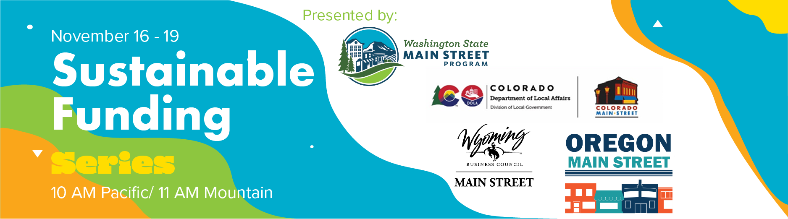
Sustainable Funding webinar miniseries, November 16-19, 10 am PT: Main Street organizations must be solvent and sustainable to continue playing their critical role in building strong communities and local economies. Oregon, Washington, Colorado, and Wyoming Main Street programs are teaming up to offer a series of webinars and discussions that outline traditional Main Street funding sources, provide best practices and innovative ideas, and encourage you to map out your own sustainable funding plan. Each morning will consist of a 45-minute webinar. Immediately after each webinar, attendees who want to continue the discussion will be invited to a breakout room for a 30-minute conversation. The webinars will be recorded. Please register in advance:
- Monday, November 16 - Overview, general strategies for adapting / Registration
Speaker: Kathy LaPlante, NMSC
Description: Kathy will provide an overview of the typical sources of funding for main street organizations and then focus on how to put together an overall funding strategy.

- Tuesday, November 17 - Private giving / Registration
Description: Private sources of funds include member or donor campaigns to well-crafted sponsorship plans that support overall main street enhancement efforts. While bringing in needed financial support, they are also an opportunity for supporters to contribute to something they believe in. This session will include examples of how communities are continuing to engage supporters through “old school” telethons to small engagement activities to keep in people’s minds to continued business support campaigns.
Speakers:
- Holli Andrews, Saline MS (MI)
- Zach Schmessar, Our Town Belfast (ME)
- Rae Gosling, Grayling Main Street (MI)

- Wednesday, November 18 - Public funding / Registration
Description: Institutional support from local government and foundations are an important source of operational and targeted financial assistance. In this session, hear about the funding model for nonprofits and use of public grant funds, partnering with local foundations to amplify fund drives, and creative ways local governments support main street efforts.
Speakers:
- Jonathan Irick, Main Street Laurens (SC)
- Connie Kincaid, Alexander Co. EDC (NC)
- Beth Duke, Center City (TX)

- Thursday, November 19 - Earned income / Registration
Description: Creativity abounds when looking at different tools to support main street enhancement efforts! In this session, you will hear about how to take your events virtual, creating stable income streams through property development and ownership, and events that generate the income you need to not only make ends meet but to help accomplish your dreams.
Speakers:
- Stacy Morris, MS Siloam Springs (AR)
- Deana Wright, Murray MS (KY)
- Liz Haynes, Old Town Cape (MO)

